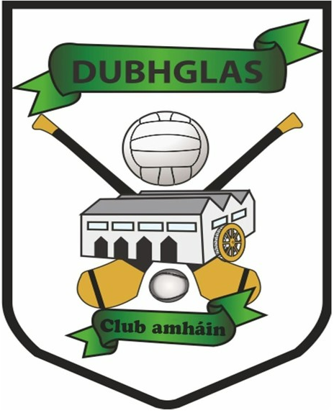
Nominations Form
GAA & One Club AGM

Officership/Position: | Nominee:

Chairperson
Vice-chairperson
Secretary
Assistant-Secretary
Treasurer
Assistant-Treasurer
Registrar
P.R.O.
Players Representative (GAA)
President | Appointed on the recommendation of the outgoing Executive Committee - not an elected position
Insurance Officer (GAA)
Language & Culture Officer

Children’s Officer
Facilities Co-Ordinator
Community Engagement Officer
Gym Co-Ordinator
Sponsorship Officer
Healthy Club Officer
Pitch Maintenance Co-Ordinator
Pitch Booking Co-Ordinator
Chair Adult Football & Hurling Committee
Delegate(s) to County Board
Delegates (s) to Seandún
Games Equipment Co-Ordinator
Responsible for consolidating all orders for footballs, sliotars, bibs, cones etc across all sections/groups, looking for savings and ensuring return of all unused gear
Player Transition Officer (GAA)
Oversees player transition from underage to adult
Hurling Development (Coaching) Officer
Football Development (Coaching) Officer
Committee

Nominee Name: ___________________________________
Contact Details ___________________________________

